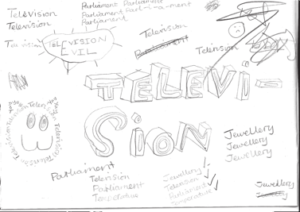
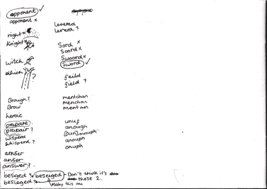
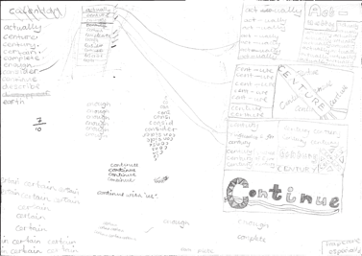
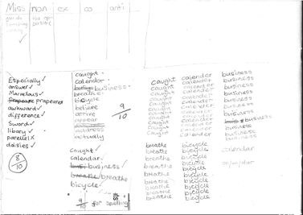
Babcock Spelling Scheme

Developing the use of spelling journals can support both teachers and pupils in many ways. They enable

  - pupils to take responsibility for their spelling learning
  - pupils to refer back to previous learning
  - teachers to see how pupils are tackling tricky bits of spelling
  - teachers and pupils to discuss spelling with parents and carers

Spelling journals
Spelling journals can take many forms and are much more than just a word book. Spelling journals can be used for

- practising strategies
- learning words
- recording rules/conventions/generalisations as an aide-memoire
- word lists of really tricky words (spelling enemies)
- ‘Having a go’ at the point of writing
- ongoing record of statutory words learnt
- investigations
- recording spelling targets or goals
- spelling tests.

In the programme, there is flexibility for journals to be set up in a variety of ways. Below are a few recommendations:

- Make sure that the journal can be used flexibly. A blank exercise book gives much more scope for pupils to try out ideas
and organise their learning than a heavily structured format.
- Model different ways of using the journal.
A class spelling journal or examples from different pupils could be used to do this.
- Give time for pupils to use their journals and to review them.
- Do the majority of spelling work in the journal.

7

Have a go sheets | These are a key component of Strategies at the point of writing. They are introduced in the Year 2 programme and then revisited in Years 3, 4, 5 and  6. Schools need to decide how Have a go will form part of their spelling policy, together with the use of spelling journals and establishing routines for attempting unknown spellings. A Have a go sheet template is provided in the Supporting Resources.  Have a go sheets can take several different forms, for example:  - a large sheet of paper on a table that pupils write on when they need to.  - sheets stuck in all pupils’ books that fold out when pupils are writing  - a book placed on the table open at a clean sheet for pupils to use.  - a page in pupils’ spelling journals.  Note: it is important that teachers have an enlarged version of a Have a go sheet displayed for modelling when writing in any curriculum area and at any time in the school day.  Introducing Have a Go:  - Model writing a sentence and being unsure about how to spell a word. Talk about the tricky part in the word and some of the choices you might have for that part. You could refer to a GPC chart to find the choices if appropriate.  - Model writing the word with two or three choices on your own enlarged version of a Have a go sheet and then model choosing the one that you think looks right and using it in your sentence. It is important that pupils learn to ask themselves the question ‘Does it look right?’ or ‘Have I seen it like this in a book?’ to help them make their choices.  - If you are still unsure of the spelling, put a wiggly line under it in the sentence to signal that this needs checking by the teacher, or the pupil if appropriate, during proofreading time.  - Model continuing with writing and not checking the correct version of the spelling at this point. This is important so that the flow of writing is not unnecessarily slowed.  5. Make sure you model this process briefly in writing in all curriculum areas.  - Pupils use their own Have a Go sheet (or group sheet) whenever they write and refer to GPC charts and other classroom displays as support, as well as specific strategies that have been taught for using at the point of writing.  - Remind them never to make more than three attempts at a word.  Misspelt words will need to be corrected in line with your school’s spelling and marking policy. Some of these words may be included in pupils’ individual word lists for learning.  To see lessons where Have a go strategies are first introduced, please refer to  Year 2 Block 1 Lessons 11 and 17.
GPC (grapheme- phoneme correspondence) choices chart | The teaching of spelling complements very much the teaching of phonics. It is anticipated that the school will draw upon the GPC charts used in their phonics programme to work alongside the teaching of spelling.

Individual whiteboards | Individual whiteboards can be used in a variety of ways to support lessons including checking spelling attempts, Quickwrite and Have a go.
Working wall | It is really useful to have a small area of display space in the classroom that can reflect current teaching focuses and provide support for pupils’ spelling as they write. GPC charts, reminders of common spelling patterns or conventions and tricky words to remember could be part of a working wall for spelling.

Learning spellings

A school policy can help inform

- the strategies for learning spellings that are being taught
- routines for learning spellings
- links with home learning.

Learning needs to happen in school and at home. There is little evidence, though, that the tradi- tional practice of learning spellings (usually 10) at home and being tested on them (usually on a Friday) is effective. However, there is a high expectation within the new National Curriculum that pupils will learn many increasingly complex words. Within the programme, learning spellings is built into each six-week block. Within the sessions a range of strategies for learning spellings are introduced and practised. This enables pupils to choose the strategies they find most effective for learning different words.

Tips for learning spellings at home

Learning at home needs to be an extension of the practice in school. Consider

- limiting the number of words to five or less a week to ensure success and enable deeper
learning
- making sure pupils and parents have access to the range of learning strategies which have been taught in school, to use in home learning
- assessing spellings in context, for example: learning spellings in a given sentence, generating sentences for each word, assessing through unseen dictated sentences
- keeping an ongoing record of words learnt and setting very high expectations of correct application in writing once a word has been learned.

The learning strategies on the next two pages are introduced incrementally throughout the pro- gramme and can then be used to support learning spellings at home.

9

Look, say, cover, write, check | This is probably the most common strategy used to learn spellings.  Look: first look at the whole word carefully and if there is one part of the word that is difficult, look at that part in more detail.  Say: say the word as you look at it, using different ways of pronouncing it if that will make it more memorable.  Cover: cover the word.  Write: write the word from memory, saying the word as you do so.  Check: Have you got it right? If yes, try writing it again and again! If not, start again – look, say, cover, write, check.
Trace, copy and replicate  (and then check) | This is a similar learning process to ‘look, say, cover, write, check’ but is about developing automaticity and muscle memory.  Write the word out on a sheet of paper ensuring that it is spelt correctly and it is large enough to trace over. Trace over the word and say it at the same time. Move next to the word you have just written and write it out as you say it. Turn the page over and write the word as you say it, and then check that you have spelt it correctly.  If this is easy, do the same process for two different words at the same time. Once you have written all your words this way and feel confident, miss out the tracing and copying or the tracing alone and just write the words.
Segmentation strategy | The splitting of a word into its constituent phonemes in the correct order to support spelling.
Quickwrite | Writing the words linked to the teaching focus with speed and fluency. The aim  is to write as many words as possible within a time constraint.  Pupils can write words provided by the teacher or generate their own examples. For example, in two minutes write as many words as possible with the /iː/ phoneme.  This can be turned into a variety of competitive games including working in teams and developing relay race approaches.
Drawing around the word to show the shape | Draw around the words making a clear distinction in size where there are ascenders and descenders. Look carefully at the shape of the word and the letters in each box. Now try to write the word making sure that you get the same shape.

10

Drawing an image around the word | This strategy is all about making a word memorable. It links to meaning in order to try to make the spelling noticeable.  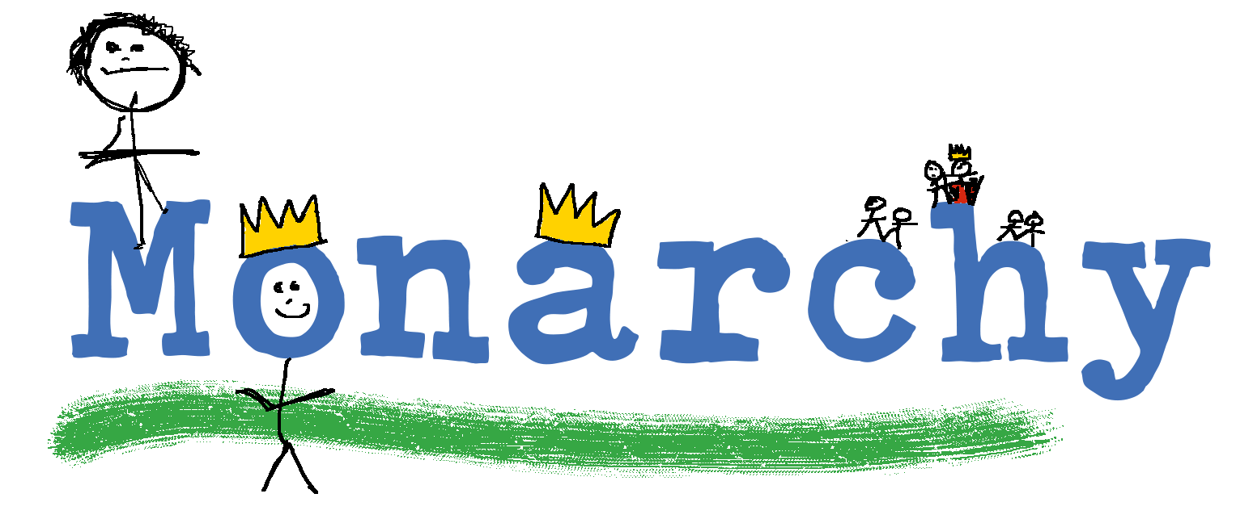  You can’t use this method as your main method of learning spellings, but it  might work on those that are just a little more difficult to remember.
Words without vowels | This strategy is useful where the vowel choices are the challenge in the words. Write the words without the vowels and pupils have to choose the correct grapheme to put in the space. For example, for the word field:
Pyramid words | This method of learning words forces you to think of each letter separately.  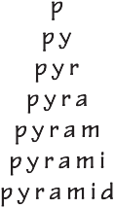  You can then reverse the process so that you end up with a diamond.
Other strategies | Other methods can include:  - Rainbow writing. Using coloured pencils in different ways can help to make parts of words memorable. You could highlight the tricky part s of the word or write the tricky part in a different colour. You could also write each letter in a different colour, or write the word in red, then overlay in orange, yellow and so on.  - Making up memorable ‘silly sentences’ containing the word  - Saying the word in a funny way – for example, pronouncing the ‘silent’ letters in a word  - Clapping and counting to identify the syllables in a word.

11

